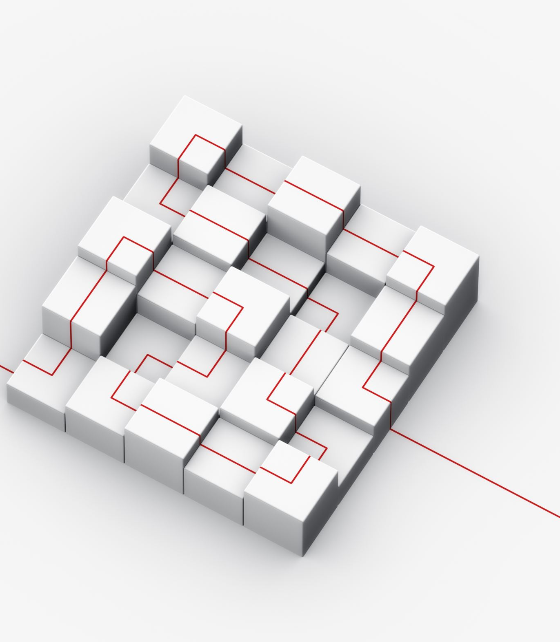
Future of Weighing & Measurement
- Metrology Milestones
- Keeping up with our evolving business
- Essential business – Weighing and Measurement

Come join the ISWM for updates on the Weighing and Measurement industry. George Washington was the one who stated we need to establish the Weighing and Measurement programs. During the last couple of years, it was apparent how much our economy depends on our industry to keep everything fair and equitable in the marketplace.
Please join us to share ideas and hear the latest in the industry. The speakers are ready. Our industry is ready to continue evolving as technology and products change.
The weather may be cold outside, but inside we are mingling and gaining knowledge.
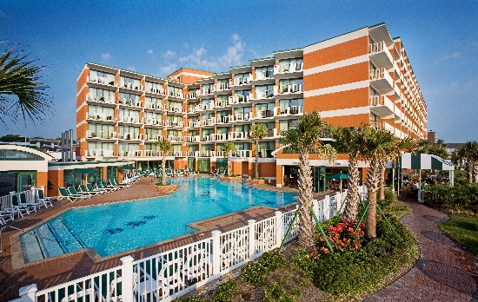
Join us February 20 through February 22, 2024, at the Holiday Inn Hotel & Suites Virginia Beach – North Beach, 3900 Atlantic Avenue, Virginia Beach, VA.
Hotel Information:
Room rates at Holiday Inn & Suites Virginia Beach – North Beach, 3900 Atlantic Avenue, Virginia Beach, VA., are $120 per night Sunday through Thursday plus a mandatory $2.00 fee and tax per standard room. The cut-off date for room reservations at the group rate at Holiday Inn & Suites is January 20, 2024. To make reservations guests can call: 757-428-1711 and use the code IWM to receive the special group rate. Below is the booking link to make reservations online: International Society of Weighing and Measurement-Booking Link

Travel Information: Norfolk International Airport is the closest airport.
Parking is free at the Holiday Inn Resort & Suites
Visa Information: Check with your local U.S. Embassy or Consulate regarding current visa requirements. If you need a letter of invitation, please email Ann Crowley at ann@iswm.org.

Sponsorships:
Sponsorships Platinum: $2,000
• Recognized sponsor of the Conference and Expo’s Icebreaker Opening Reception. Sponsorship acknowledgment and appropriate signage at the Opening Reception of ISWM’s Conference and Expo.
• Half-page ad in the ISWM Conference and Expo Program.
• Prominence on all sponsorship listing/signage.
• Distinctive identification badges for all company employees attending the Conference and Expo.

Gold: $1,500
• Recognized sponsor of the 2012 ISWM Conference and Expo.
• Gold sponsors will have their company logo displayed on ISWM’s online Membership Directory.
• Third-page ad in the 2012 ISWM Conference and Expo Program.
• Prominence on all sponsorship listings/signage.
• Distinctive identification badges for all company employees attending the Conference and Expo.

Silver: $1,000

• Recognized sponsor of the 2012 ISWM Conference and Expo.
• Quarter-page ad in the 2012 Conference and Expo Program.
• Listing on all sponsorship rosters/signage.
• Distinctive identification badges for all company employees attending the Conference and Expo

Education Session Coffee Break $400 sponsorship for one day.
Two sponsorships available. Who wouldn’t love the company that brought them a hot cup of coffee to combat the morning slump! Make your company the hero of the ISWM Conference as a Coffee Break sponsor at the Education sessions. You will be identified as the Coffee Break sponsor with signage bearing your company name and logo, and you will also be entitled to set up a tabletop display in the education session hallway at the time of your sponsored Coffee Break. Also, your company will be acknowledged in the ISWM Conference and Expo Program for its sponsorship. If you are interested in sponsoring, go to iswm.org under Events and download the full exhibit and sponsorship prospectus.
Speakers:
Don Onwiler – National Conference of Weights and Measures - Executive Director at National Conference on Weights & Measures update.

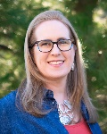 Elizabeth Benham – Physical Scientist, Metric Program Leader Since 2005, Ms. Benham has served as the nation's focal point for voluntary conversion to the International System of Units (SI), commonly known as the metric system. As Metric Coordinator, she provides information and assistance to Federal, State and Local weights and measures officials, business, industry, educational institutions, and the public concerning the metric system (SI) and identifies opportunities for increasing the understanding and use of the SI measurement system in trade and commerce. Ms. Benham is actively involved in Science, Technology, Engineering, and Mathematics (STEM) education and outreach activities.
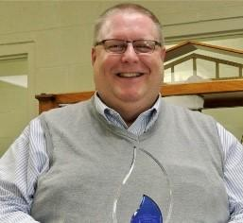 Mark Ruefenacht – ASTM E617 and Proficiency Testing

Metrology, Statistics, Uncertainty Standards Development & Research Instructor at National Institute of Standards and Technology.
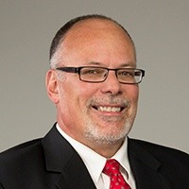 Jeff Canfield – Regional Manager at Rice Lake Weighing.
Presenting on sales for service professionals.
Exhibit Information:
Exhibit set up will begin on February 20, 2024, at 10 am. All Exhibits need to be removed by 11:00 am on Friday, February 23, 204. All equipment shipped should be marked with the name and date of the Conference. All equipment crates or material needs to be on wheels. The hotel cannot move the crates as there is no pallet jack on the property. Equipment should arrive no sooner than 3 days before the conference. All boxes must be removed by one day after the conference.
The exhibit tables are one six-foot table with cloth skirting, two chairs, and a wastebasket.

Call for Nominations for Awards: (Nominations to be completed by January 15, 2024.)

Mark Pickell Award:
Recognizing and honoring that member whose outstanding activities and efforts during the preceding year or years has contributed greatly to strengthening the effectiveness, benefits, and growth of his/her local Division of ISWM.
In memory of Mark W. Pickell, who was associated with the weighing industry and NSMA from the early publication days of Scale Journal (now Weighing and Measurement Magazine). Mr. Pickell served as Secretary-Treasurer of NSMA for years.

Purpose
The Mark Pickell award was created to recognize and honor that member whose outstanding activities and efforts during the preceding year or years has contributed greatly to strengthen the effectiveness, benefits, and growth of his/her local Division of ISWM.

Eligibility Requirements
The candidate must be a member in good standing of the Division placing the nomination for at least one year. The candidate must be active in his/her division affairs during the year in which he/she is nominated, regularly attend meetings, and help when asked.
The candidate does not have to be active on an international level, nor present at the society Conference. The candidate may not be nominated by his/her division for another international award in the same year. Candidates may be nominated more than once, but not in two consecutive years.

Thomas "Mic" Hendrick Award
Recognizing an individual for his/her discovery or successful application of a principle or concept which has benefited the weighing industry (formerly known as the Technical Excellence Award).
Established in 1979, the Thomas "Mic" Hendrick memorial Award for Technical Excellence (formerly known as the Technical Excellence Award) is sponsored and funded by the ISWM.

Purpose
To recognize an individual for his/her discovery or successful application of a principle or concept which has benefited the weighing industry.

Eligibility Requirements
The recipient may be any person credited with a discovery or successful application of a principle or concept which has benefited the weighing industry. The principle must be of a technical nature, have been introduced to the weighing industry within the last 100 years, be unique, represent an improvement to increase efficiency and/or accuracy of weighing equipment and have been in use for a reasonable time by a significant portion of the industry. It must be of economic significance to the weighing industry and foster further advancements in the industry by building on the concept.
The award may be presented posthumously, but preference will be given to a living person. The recipient or some living person or representative of an organization must be interested enough to be at the conference to accept, receive, and acknowledge the award.
Nominations can be sent to the ISWM headquarters and will be forwarded to the Selection Committee.

Lady of the Year Award
To encourage active participation in the Society on the part of wives of members and the women in the weighing industry, and to recognize their valuable contributions to the Society and the industry.
Sponsored by a trust fund in care of ISWM set up in 1979 by Raymond C. and Charlotte M. Canfield, Pittsburgh, PA.

Purpose
To encourage active participation in the Society on the part of wives of members and the women in the weighing industry and to recognize their valuable contributions to the Society and the industry.

Eligibility Requirements
The candidate should be a member in good standing of the International Society of Weighing and Measurement or the wife of a member in good standing. The candidate should present at the Society Conference. The candidate must participate in the guest program seminar and at least one other guest program activity during the conference; or be registered as a conference attendee. The candidate shall have been active in ISWM Division and District activities. Consideration also will be given for participation in activities of her church, her community, and other outside organizations. Paid staff members of ISWM shall not be eligible for this award.

Nominations
Each Division may submit at least one nomination for the award, and more than one may be submitted. Nominations shall be sent to the ISWM headquarter office no later than thirty (30) days prior to the Society Conference and shall be no more than two pages in length. Nominations shall include pertinent information on the activities and achievements of the candidate in ISWM, in her community, church, and other outside organizations.

Earl Curl Award
Recognizing the outstanding Division of ISWM. The Earl Curl Award was established in 1961 and is donated each year by Nicol Scales, LP, Dallas, Texas.

In Memory of Earl Curl, General Manager of the Western Weighing and Inspection Bureau, Chicago, Illinois, who served as President of National Scale Men's Association in 1949-50.

Purpose
Originally intended as a membership incentive award to be won by the local Division which had the largest percentage of increase in membership from one annual meeting to the next, the award has evolved into one which recognizes the outstanding division of ISWM.

Eligibility Requirements
The Division must meet both eligibility requirements as listed below: 1. Increase in membership an average of 5% or more in the last (2) years. 2. Two or more meetings during each of the last (2) years.

Selection Considerations
The committee will make the selection based on the following considerations: 1. Additional meetings have been held during the last (2) years. 2. Quality of special programs during meetings. 3. Quality of speakers at meetings. 4. Educational classes at meetings. 5. Programs to benefit other Divisions of ISWM.

Nominations
Each eligible Division may submit to the selection committee a presentation showing why it should be awarded the Earl Curl Award. Only one division will be awarded the Earl Curl Award during the year.

Woody Woodland Memorial Award
This award is intended to honor a person who, by his/her own efforts and services, has contributed in an outstanding manner to the scale and weighing industry.

In Memory of
J.E. "Woody” Woodland, who dedicated his entire life to the weighing industry and to the people in it, and who passed away in 1948 on the day he was elected President of National Scale Men’s Association.

Purpose
The award is intended to honor a person who, by his/her own efforts and services, has contributed in an outstanding manner in the scale and weighing industry.

Nominations
Each Division of the Society is asked to submit a nomination to the Chairperson of the nominations committee.

ISWM Outstanding Young Professional Award

Purpose
The purpose of this award is to recognize an ISWM member, 45 years or younger, who has contributed in a meaningful way to the ISWM and the weighing industry.

How to Nominate
Nominations must be made for the award by an ISWM member in good standing. ISWM members wishing to make nominations for the ISWM Outstanding Young Professional Award should present in writing a brief biographical sketch of the nominee, along with a discussion of the person's contributions to the ISWM and the weighing industry. Presentations should be limited to two (2) pages. Particular attention should be devoted to explaining why the nominee qualifies for the award and to making certain that the nominee meets the selection criteria. The award will be based entirely on merit and will not necessarily be presented each year. Nominations should be sent to ISWM Headquarters at least 60 days prior to the start of the ISWM Conference and Expo.

Outstanding New Product Award (Kardux Cup)
Recognizing a company, group, or individual for the most outstanding new technical achievement of the past two years that positively impacts the weighing and measurement industry.
Established in 1996, the Outstanding New Product Award (Kardux Cup), is sponsored and funded by the International Society of Weighing and Measurement. Named for Ken Kardux, of Kg Systems, Inc. whose inspiration was instrumental in the implementation of the award, and who generously contributed funds towards the purchase of the original perpetual trophy.

Purpose
To recognize a company, group or individual for the most outstanding new technical achievement of the past two years that positively impacts the weighing and measurement industry.

Award Process
The Outstanding New Product Award selection committee shall consist of the First Vice President as Chairperson. The Chairperson will select (4) to (9) members for a total of (5) to (10) members. The members shall be selected from a cross section of the Weighing and Measurement industry, such as manufacturers of scales, load cells, indicators, printers, and components, wholesale distributors, dealers, users, regulators, inspectors, and government officials. The committee will meet during the Society Conference and review all products and documents submitted. The committee will choose three finalists, and interview each of the finalists. The committee will inform the three finalists of the date and time the award will be presented and encourage them to attend the event. Once the interviews have been completed, the committee will meet and come to a majority decision on the winner.

Eligibility Requirements
1. Product data, picture, and application is to be submitted 30 days before the Society Conference. This information will then be distributed to committee members. 2.Product is to be put on display in the New Product Showcase at the Society Conference. 3.Admission to the New Product Showcase will be granted only to current exhibitors. 4.The product must have been released for publication or use during the past (2) years. 5.The achievement must represent a significant technical advancement.

Most Outstanding Exhibit Award
Recognizing a company that exhibits at the Society Conference for having the most outstanding exhibit.

Purpose
To recognize a company that exhibits at the Society Conference for having the Most Outstanding Exhibit.

Eligibility Requirements
The recipient must be exhibiting at the current Society Conference. The exhibit will be judged on overall quality, product presentation, booth staffing, personal appearance, helpfulness to attendees, and assistance with technical and application questions.

CONFERENCE & EXPO ATTENDEE REGISTRATION FORM

International Society of Weighing & Measurement
ADDRESS: P.O. Box 148474, Nashville, TN 37214
PHONE: 715-651-9123
EMAIL: staff@iswm.org

Conference Registrant (please print – Only ONE Registrant Per Form)
Name: ___________________________________________________
Nickname or First Name (to appear on badge): __________________
Firm: ____________________________________________________
Address: _________________________________________________
City: ________________ State: _____________ Zip: ________ Country: ____________
Telephone: ___________________________ Email: __________________________________

Guest:
Name of Guest registering: ____________________________________

Employee Classification:
Please check the category that best describes your business:
W&M Industry Manufacturer Consumer
W&M Industry Dealer/Distributor Regulatory Official
Retired Importer/Exporter

Registration Packages
Full Conference: Registration $225.00
Includes admission to the Icebreaker Reception, Educational Program, Expo, and lunch on Wednesday and Thursday. (Proficiency testing is not included)

One-Day Registration: $ 175.00
Includes admission to Icebreaker Reception on Tuesday evening, the Opening General Session, One-Day Expo, and lunch on Wednesday or Thursday. (Proficiency Testing is not included)
Wednesday or Thursday

Registration Fees (Please Circle choice):
Register by: January 20 Register after January 20
Member Non-Member Member Non-Member

Full Conference Registration $225 $300 $295 $345
Proficiency Test $100 $125 $125 $155
Certified Weighing Technician Test $ 50 $ 75 $ 75 $100

One Day Registration:
Wednesday $175 $250 $200 $275
Thursday $175 $250 $200 $275

Payment: TOTAL AMOUNT DUE $____________________
Check enclosed (payable to ISWM, US funds only) Check #__________

Credit Card: VISA Master Card American Express
Account No: ______________________________________ Exp Date: __________________
Name on Card: ____________________________________
Signature: ________________________________________
I authorize ISWM to charge my credit card for the amount indicated above.

Accommodations:
Room rates at Holiday Inn & Suites Virginia Beach – North Beach, 3900 Atlantic Avenue, Virginia Beach, VA., are $120 per night Sunday through Thursday plus a mandatory $2.00 fee and tax per standard room. The cut-off date for room reservations at the group rate at Holiday Inn & Suites is January 20, 2024. To make reservations guests can call: 757-428-1711 and use the code IWM to receive the special group rate. Below is the booking link to make reservations online: International Society of Weighing and Measurement-Booking Link

Cancellation Policy:
A written cancellation notice is required and must be received in writing by January 20, 2024. A 25% service fee will be retained on all cancellations. No refunds will be given after Friday, January 20, 2024.

Special Services:
The International Society of Weighing & Measurement supports the Americans with Disabilities Act, which promotes public accessibility for the disabled. If you require special equipment or services, please attach a written description of your needs. We will contact you in advance to ensure your needs are met.

GOT QUESTIONS?
Contact Ann Crowley for answers:
Address: P.O. Box 148474, Nashville, TN 37214 • Phone: 715-651-9123 • Email: ann@iswm.org

EXHIBIT/SPONSORSHIP APPLICATION AND CONTRACT

International Society of Weighing & Measurement
ADDRESS: P.O. Box 148474, Nashville, TN 37214
PHONE: 715-651-9123 EMAIL: ann@iswm.org

Exhibitor:
Company Name: ___________________________________________________
Contact Name: ___________________________________________________
Address: _________________________________________________
City: ________________ State: _____________ Zip: ________ Country: ____________
Telephone: ___________________________ Email: __________________________________

Other Registrant or Attendees: (one with 10’ x 10’)
Name registering: ______________________________________
______________________________________
Extra Registration (use extra forms) - $225 each.

Fees:
The exhibit space will be rented according to the following fee structure (check one):
Members Non-Members
10’ x 10’ Includes one (1) full Conference and $1,000 $1,500
Exposition registration & Sponsorship.
20’ x 10’ Includes two (2) full Conference and $1,800 $2,400
Exposition registrations. & Sponsorship
After January 15, 2024 Members Non-Members
10’ x 10’ Includes one (1) full Conference and $1,500 $1,900
Exposition registration & Sponsorship.
20’ x 10’ Includes two (2) full Conference and $2,400, $2,800
Exposition registrations & Sponsorship.
TOTAL FEE $ ________________

Selection:
Select space as shown on the Expo Floor Plan. List only one number per choice.
1st choice ________ 2nd choice __________

Promotions:
Describe in 50 words or less (exactly as you want it to appear in the official promotions) the products, or the services you will be exhibiting. Attach a description to this application or email Ann Crowley at ann@iswm.org.

Sponsorship: Please indicate your sponsorship level:
PREMIER
___ Platinum - $2,000 ___ Gold - $1,500 ___ Silver - $1,000
COFFEE BREAK SPONSOR
____ One Day - $400.00 ___ Two Days - $700
SPONSORSHIP TOTAL: _________________

Door Prize:
Will you donate a door prize or the ISWM All Expo Card drawings? ___ Yes ___ No

Payment:
Booth Fees Total: _____________________
Sponsorship Total: _____________________
Extra Attendees: $____________________
TOTAL AMOUNT DUE $____________________
Check enclosed (payable to ISWM, US funds only) Check #__________

Credit Card: VISA Master Card American Express
Account No: ______________________________________ Exp Date: __________________
Name on Card: ____________________________________
Signature: ________________________________________
I authorize ISWM to charge my credit card for the amount indicated above.

Authorization:
I am an authorized representative of the company with full power and authority to sign and deliver this application. The company listed on this application agrees to comply with all policies, rules, and regulations contained in the Exhibitor Prospectus and all policies, rules, and regulations adopted after publication of the prospects, which we accept as part of the agreement.
Company: ___________________________________________________
Authorized Name: ___________________________ Title: ___________________
Signature: ___________________________________ Date: ___________________

Accommodations:
Room rates at Holiday Inn & Suites Virginia Beach – North Beach, 3900 Atlantic Avenue, Virginia Beach, VA., are $120 per night Sunday through Thursday plus a mandatory $2.00 fee and tax per standard room. The cut-off date for room reservations at the group rate at Holiday Inn & Suites is January 20, 2024. To make reservations guests can call: 757-428-1711 and use the code IWM to receive the special group rate. Below is the booking link to make reservations online: International Society of Weighing and Measurement-Booking Link

Cancellation Policy:
A written cancellation notice is required and must be received in writing by January 20, 2024. A 25% service fee will be retained on all cancellations. No refunds will be given after Friday, January 20, 2024.

Special Services:
The International Society of Weighing & Measurement supports the Americans with Disabilities Act, which promotes public accessibility for disabled people. If you require special equipment or services, please attach a written description of your needs. We will contact you in advance to ensure your needs are met.

GOT QUESTIONS?
Contact Ann Crowley for answers:
Address: P.O. Box 148474, Nashville, TN 37214 • Phone: 715-651-9123 • Email: ann@iswm.org

Return signed application and payment to:
International Society of Weighing & Measurement
P.O. Box 148474 Nashville, TN 37214
PH: (715) 651-9123 Email: ann@iswm.org

